HTTP Method | Route | Description | Role Required | Request Body | Expected Response
POST | /api/auth/register | egister a new user account (Organiser or Participant) | None (public) | { email, password, firstName, lastName, roleId } | 201 Created - { userId, email, token, role }
POST | /api/auth/login | Authenticate user and return JWT token. | None(public) | { email, password } | 200 OK - { userId, email, token, role }
GET | /api/users/{userId} | Retrieve user profile information | uthenticated (self or admin) | None | 200 OK - { userId, email, firstName, lastName, role, createdDate }
PUT | /api/users/{userId} | Update user profile (name, contact details) | Authenticated (self) | { firstName, lastName, phoneNumber } | 200 OK - { userId, firstName, lastName, modifiedDate }
GET | /api/events | List all events ( filterd by date, lovation, status) | any | Query params: status, dateFrom, dateTo, location | 200 OK - { events: [ { eventId, name, date, location, distance, capacity } ] }
POST | /api/events | Create new event (Organiser only) | Organiser | { name, description, date, location, distance, capacity } | 01 Created - { eventId, name, status, createdDate }
GET | /api/events/{eventide} | Retrieve event details and associated categories | Any | None | 200 OK - { eventId, name, description, date, location, distance, categories: [ { categoryId, name } ] }
PUT | /api/events/{eventide} | Update event details (Organiser only) | Organiser | { name, description, date, location, distance, capacity, status } | 200 OK - { eventId, modifiedDate }
DELETE | /api/events/{eventide} | Delete event (Organiser only) | Organiser | None | 204 No Content
GET | /api/categories | List all available | any | None | 200 OK - { categories: [ { categoryId, name, description, minAge, maxAge } ] }
POST | /api/categories | Create new category (Organiser only) | Organiser | { name, description, minAge, maxAge } | 201 Created - { categoryId, name }
POST | /api/enrollments | Enroll participant in specific event/category | Participant | { eventId, categoryId, emergencyContact } | 201 Created - { enrollmentId, status, enrollmentDate }
GET | /api/enrollments/user/{userId} | Get participant’s current and past enrollments | Authenticated (self) | None | 200 OK - { enrollments: [ { enrollmentId, eventName, categoryName, status, enrollmentDate } ] }
GET | /api/events/{eventId}/enrollments | Get all enrollments for an event | Organiser | Query params: categoryID, status | 200 OK - { enrollments: [ { enrollmentId, userName, email, categoryName, status, enrollmentDate } ] }
POST | /api/results | Record participant result (Organiser only) | Organiser | { enrollmentId, finishTime, position, chipNumber } | 201 Created - { resultId, position, finishTime, status }
GET | /api/results/user/{userID} | Get participant’s personal race results and history | Authenticated (self) | None | 200 OK - { results: [ { resultId, eventName, categoryName, position, finishTime, eventDate } ] }
GET | /api/events/{eventide}/results | Get event results/leaderboard (public) | Any | Query params: categoryID, top (limit results) | 200 OK – { results: [ { position, userName, finishTime, chipNumber, categoryName } ] }

CREATE DATABASE RaceDay
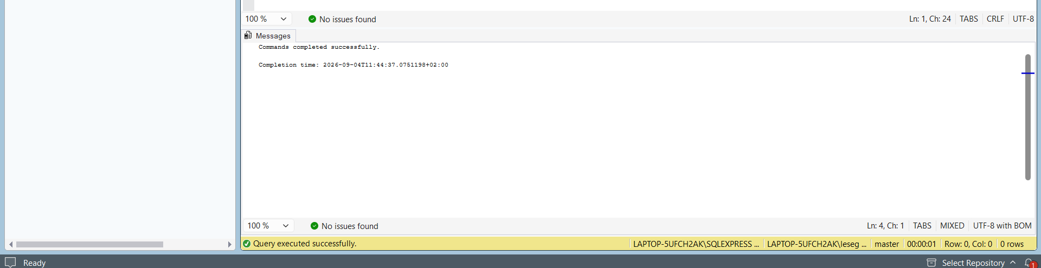
CREATE TABLE [dbo].[UserRole] (
[UserRoleId] [uniqueidentifier] NOT NULL PRIMARY KEY DEFAULT NEWID(),
[RoleName] [nvarchar](50) NOT NULL UNIQUE,
[Description] [nvarchar](255),
[CreatedDate] [datetime] NOT NULL DEFAULT GETUTCDATE()
);
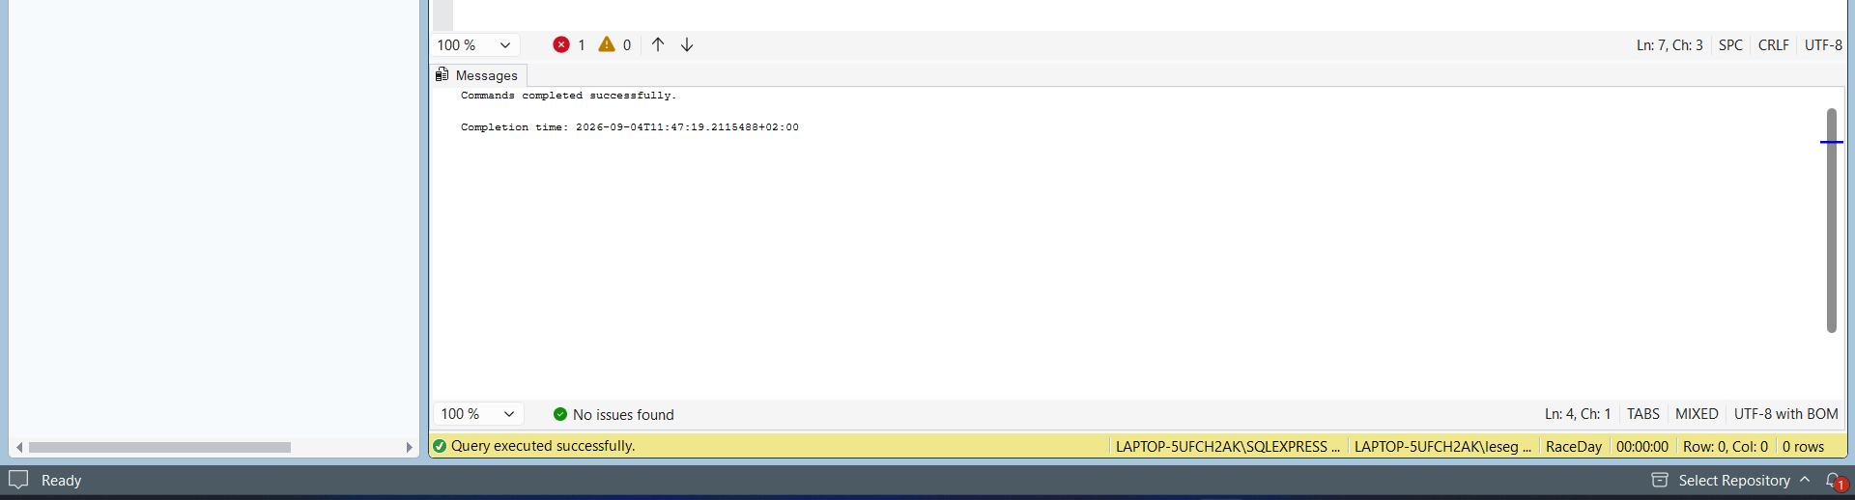
CREATE TABLE [dbo].[User] (
[UserId] [uniqueidentifier] NOT NULL PRIMARY KEY DEFAULT NEWID(),
[Email] [nvarchar](100) NOT NULL UNIQUE,
[PasswordHash] [nvarchar](255) NOT NULL,
[FirstName] [nvarchar](50) NOT NULL,
[LastName] [nvarchar](50) NOT NULL,
[PhoneNumber] [nvarchar](20),
[UserRoleId] [uniqueidentifier] NOT NULL,
[IsActive] [bit] NOT NULL DEFAULT 1,
[CreatedDate] [datetime] NOT NULL DEFAULT GETUTCDATE(),
[ModifiedDate] [datetime] DEFAULT GETUTCDATE(),
CONSTRAINT [FK_User_UserRole] FOREIGN KEY ([UserRoleId]) REFERENCES [dbo].[UserRole]([UserRoleId])
);

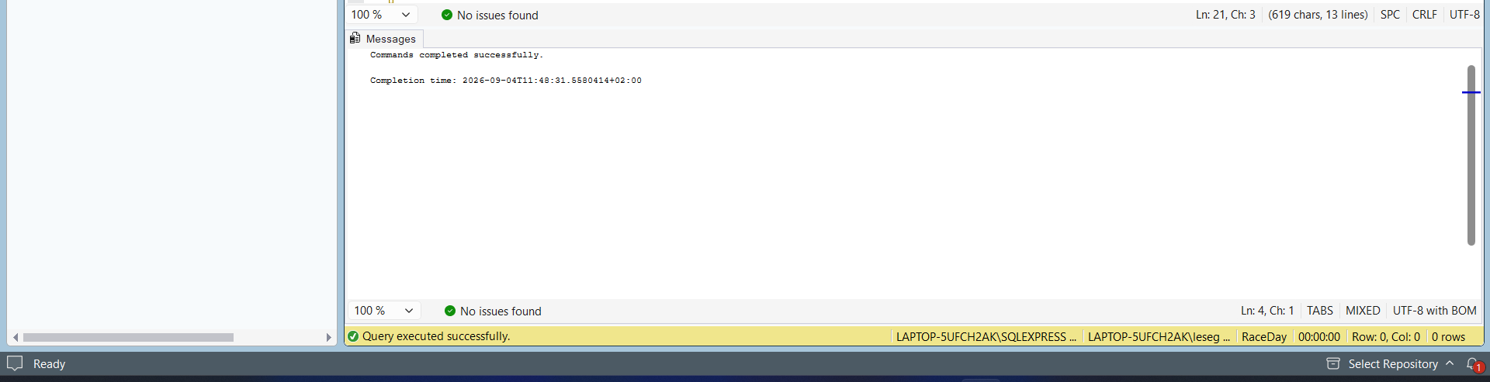
CREATE TABLE [dbo].[Event] (
[EventId] [uniqueidentifier] NOT NULL PRIMARY KEY DEFAULT NEWID(),
[EventName] [nvarchar](100) NOT NULL,
[Description] [nvarchar](max),
[EventDate] [datetime] NOT NULL,
[Location] [nvarchar](100) NOT NULL,
[Distance] [decimal](5,2) NOT NULL,
[Capacity] [int] NOT NULL,
[OrganiserId] [uniqueidentifier] NOT NULL,
[Status] [nvarchar](20) NOT NULL DEFAULT 'Scheduled',
[CreatedDate] [datetime] NOT NULL DEFAULT GETUTCDATE(),
[ModifiedDate] [datetime] DEFAULT GETUTCDATE(),
CONSTRAINT [FK_Event_Organiser] FOREIGN KEY ([OrganiserId]) REFERENCES [dbo].[User]([UserId])
);
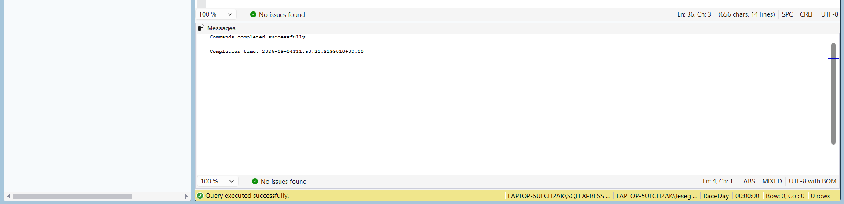
CREATE TABLE [dbo].[Category] (
[CategoryId] [uniqueidentifier] NOT NULL PRIMARY KEY DEFAULT NEWID(),
[CategoryName] [nvarchar](50) NOT NULL,
[Description] [nvarchar](255),
[MinAge] [int],
[MaxAge] [int],
[CreatedDate] [datetime] NOT NULL DEFAULT GETUTCDATE()
);
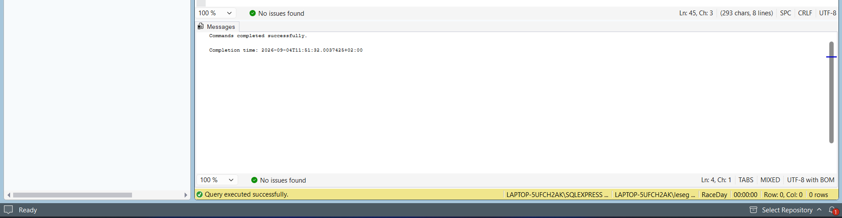
CREATE TABLE [dbo].[EventCategory] (
[EventCategoryId] [uniqueidentifier] NOT NULL PRIMARY KEY DEFAULT NEWID(),
[EventId] [uniqueidentifier] NOT NULL,
[CategoryId] [uniqueidentifier] NOT NULL,
[CreatedDate] [datetime] NOT NULL DEFAULT GETUTCDATE(),
CONSTRAINT [FK_EventCategory_Event] FOREIGN KEY ([EventId]) REFERENCES [dbo].[Event]([EventId]),
CONSTRAINT [FK_EventCategory_Category] FOREIGN KEY ([CategoryId]) REFERENCES [dbo].[Category]([CategoryId]),
CONSTRAINT [UQ_EventCategory] UNIQUE ([EventId], [CategoryId])
);
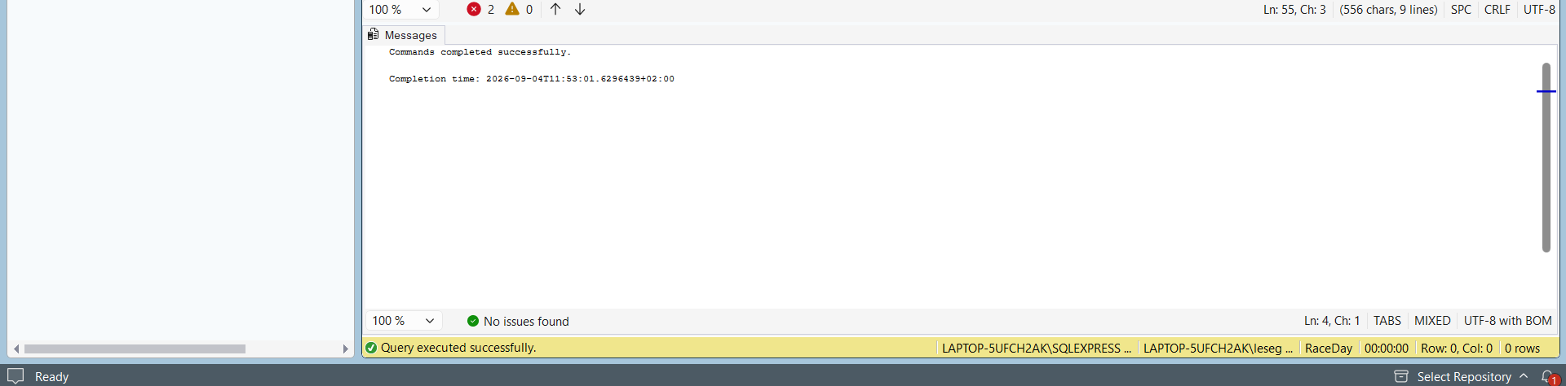
CREATE TABLE [dbo].[Enrolment] (
[EnrolmentId] [uniqueidentifier] NOT NULL PRIMARY KEY DEFAULT NEWID(),
[ParticipantId] [uniqueidentifier] NOT NULL,
[EventCategoryId] [uniqueidentifier] NOT NULL,
[EmergencyContact] [nvarchar](100),
[EnrolmentStatus] [nvarchar](20) NOT NULL DEFAULT 'Active',
[EnrolmentDate] [datetime] NOT NULL DEFAULT GETUTCDATE(),
[CreatedDate] [datetime] NOT NULL DEFAULT GETUTCDATE(),
[ModifiedDate] [datetime] DEFAULT GETUTCDATE(),
CONSTRAINT [FK_Enrolment_Participant] FOREIGN KEY ([ParticipantId]) REFERENCES [dbo].[User]([UserId]),
CONSTRAINT [FK_Enrolment_EventCategory] FOREIGN KEY ([EventCategoryId]) REFERENCES [dbo].[EventCategory]([EventCategoryId])
);

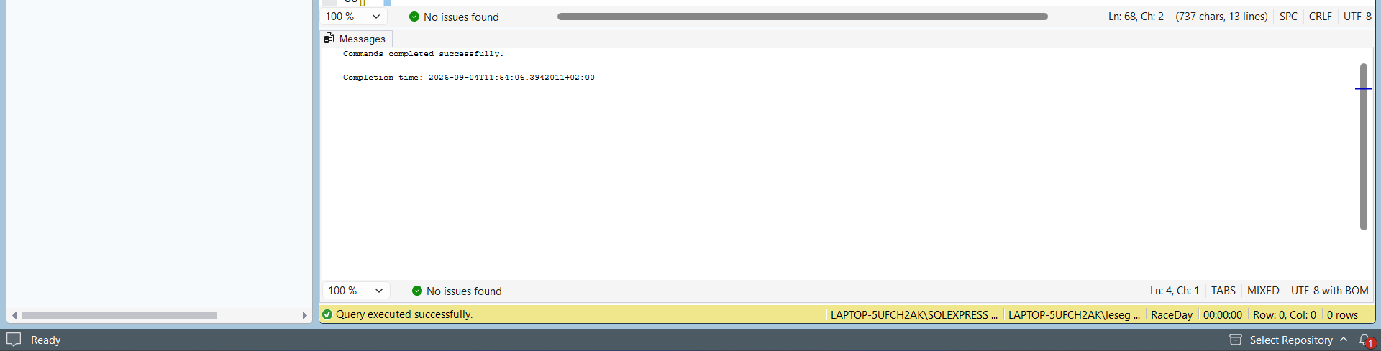
CREATE TABLE [dbo].[Result] (
[ResultId] [uniqueidentifier] NOT NULL PRIMARY KEY DEFAULT NEWID(),
[EnrolmentId] [uniqueidentifier] NOT NULL UNIQUE,
[FinishTime] [time] NOT NULL,
[Position] [int] NOT NULL,
[ChipNumber] [nvarchar](20),
[Status] [nvarchar](20) NOT NULL DEFAULT 'Finished',
[CreatedDate] [datetime] NOT NULL DEFAULT GETUTCDATE(),
CONSTRAINT [FK_Result_Enrolment] FOREIGN KEY ([EnrolmentId]) REFERENCES [dbo].[Enrolment]([EnrolmentId])
);
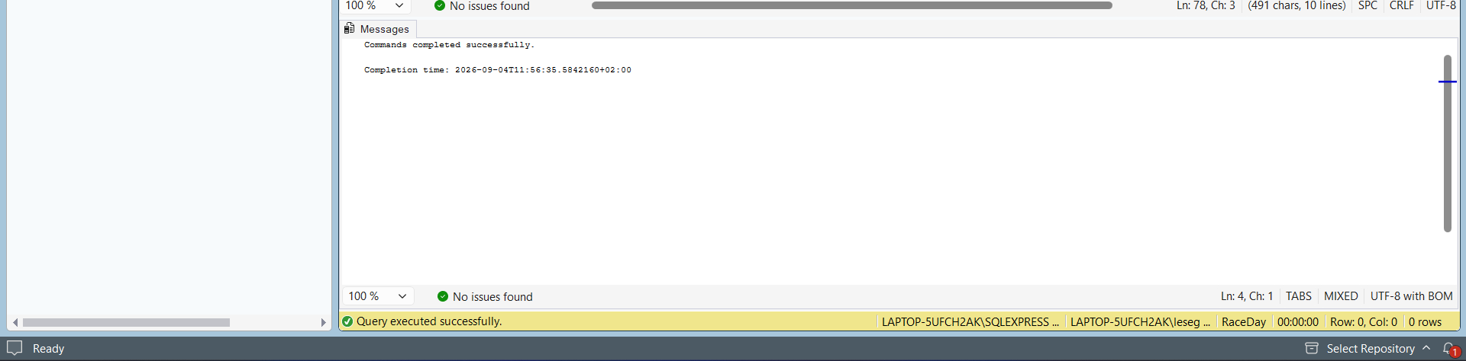
INSERT INTO [dbo].[UserRole] ([RoleName], [Description]) VALUES
(N'Organiser', N'Event organizer who creates and manages events'),
(N'Participant', N'Person who participates in events');

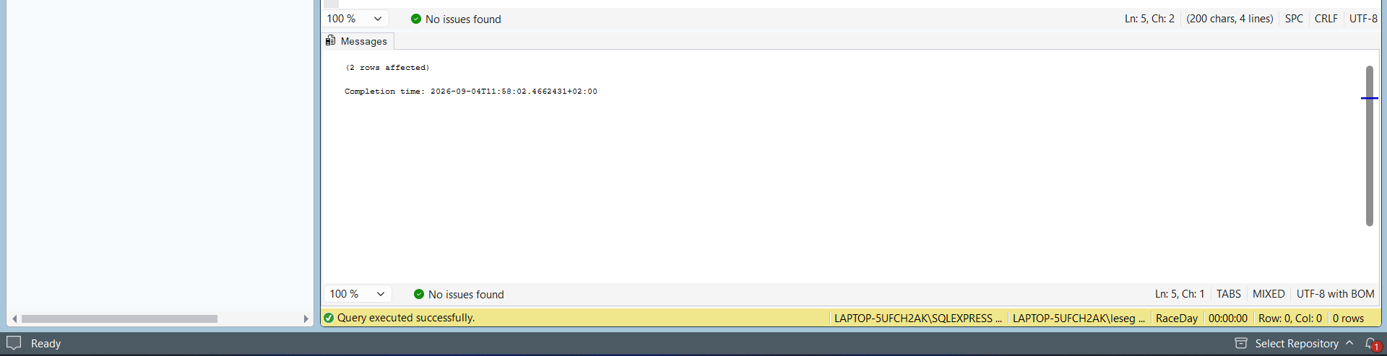
ECLARE @OrgRoleId UNIQUEIDENTIFIER = (SELECT [UserRoleId] FROM [dbo].[UserRole] WHERE [RoleName] = 'Organiser');
DECLARE @PartRoleId UNIQUEIDENTIFIER = (SELECT [UserRoleId] FROM [dbo].[UserRole] WHERE [RoleName] = 'Participant');
INSERT INTO [dbo].[User] ([Email], [PasswordHash], [FirstName], [LastName], [UserRoleId]) VALUES
(N'organiser1@raceday.co.za', N'hashed_password_1', N'Mandla', N'Masemola', @OrgRoleId),
(N'organiser2@raceday.co.za', N'hashed_password_2', N'Sarah', N'Mahlomuza', @OrgRoleId);
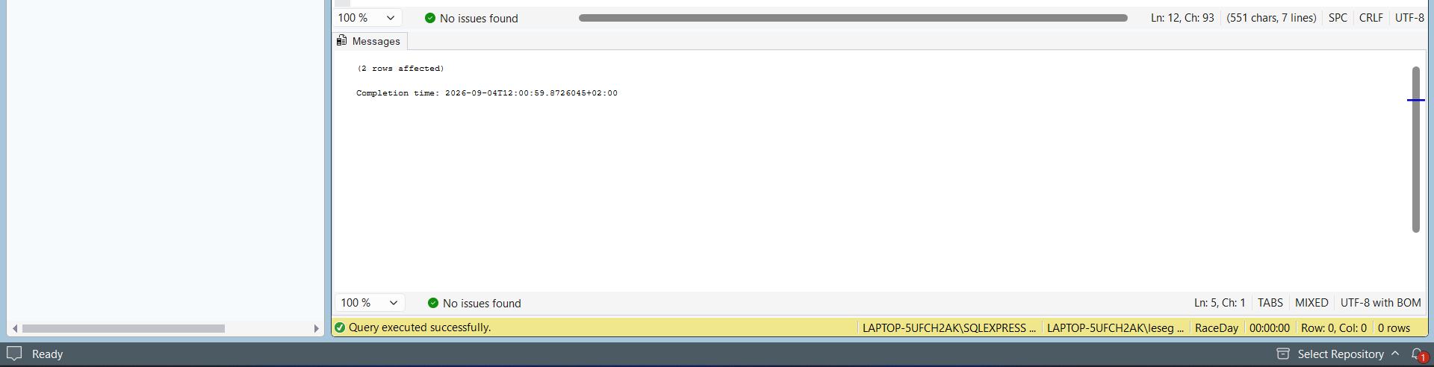
DECLARE @OrgRoleId UNIQUEIDENTIFIER = (SELECT [UserRoleId] FROM [dbo].[UserRole] WHERE [RoleName] = 'Organiser');
DECLARE @PartRoleId UNIQUEIDENTIFIER = (SELECT [UserRoleId] FROM [dbo].[UserRole] WHERE [RoleName] = 'Participant');

-- Insert Users (Participants)
INSERT INTO [dbo].[User] ([Email], [PasswordHash], [FirstName], [LastName], [UserRoleId]) VALUES
(N'participant1@raceday.co.za', N'hashed_password_3', N'Nkulu', N'Ntuli', @PartRoleId),
(N'participant2@raceday.co.za', N'hashed_password_4', N'Lindiwe', N'Mabena', @PartRoleId),
(N'participant3@raceday.co.za', N'hashed_password_5', N'Michael', N'Sithole', @PartRoleId);

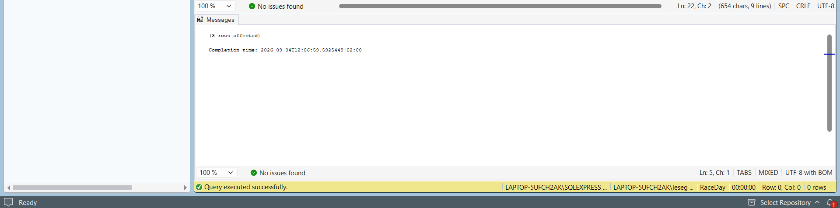
DECLARE @Org1 UNIQUEIDENTIFIER = (SELECT [UserId] FROM [dbo].[User] WHERE [Email] = 'organiser1@raceday.co.za');
DECLARE @Part1 UNIQUEIDENTIFIER = (SELECT [UserId] FROM [dbo].[User] WHERE [Email] = 'participant1@raceday.co.za');
DECLARE @Part2 UNIQUEIDENTIFIER = (SELECT [UserId] FROM [dbo].[User] WHERE [Email] = 'participant2@raceday.co.za');
DECLARE @Part3 UNIQUEIDENTIFIER = (SELECT [UserId] FROM [dbo].[User] WHERE [Email] = 'participant3@raceday.co.za');

-- Insert Events
INSERT INTO [dbo].[Event] ([EventName], [Description], [EventDate], [Location], [Distance], [Capacity], [OrganiserId], [Status]) VALUES
(N'Pretoria 10K Run', N'Annual 10 kilometer running event', DATEFROMPARTS(2026, 10, 15), N'Pretoria', 10.0, 500, @Org1, N'Scheduled'),
(N'Johannesburg Half Marathon', N'Half marathon event for all fitness levels', DATEFROMPARTS(2026, 11, 20), N'Johannesburg', 21.1, 1000, @Org1, N'Scheduled'),
(N'Cape Town Cycle Challenge', N'50km cycling event', DATEFROMPARTS(2026, 12, 10), N'Cape Town', 50.0, 300, @Org1, N'Scheduled');

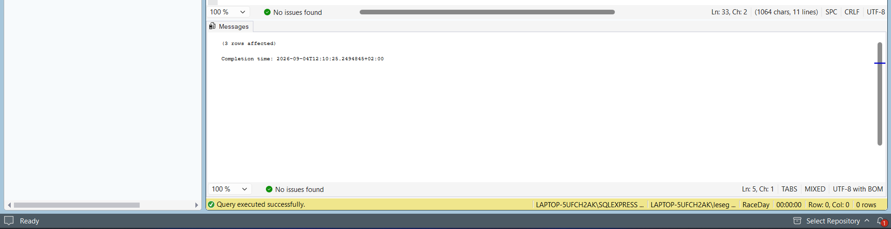
DECLARE @Event1 UNIQUEIDENTIFIER = (SELECT [EventId] FROM [dbo].[Event] WHERE [EventName] = 'Pretoria 10K Run');
DECLARE @Event2 UNIQUEIDENTIFIER = (SELECT [EventId] FROM [dbo].[Event] WHERE [EventName] = 'Johannesburg Half Marathon');
DECLARE @Event3 UNIQUEIDENTIFIER = (SELECT [EventId] FROM [dbo].[Event] WHERE [EventName] = 'Cape Town Cycle Challenge');
INSERT INTO [dbo].[Category] ([CategoryName], [Description], [MinAge], [MaxAge]) VALUES
(N'5K', N'5 kilometer category', NULL, NULL),
(N'10K', N'10 kilometer category', NULL, NULL),
(N'Half Marathon', N'21.1 kilometer category', NULL, NULL),
(N'U18', N'Under 18 years', 0, 18),
(N'18-35', N'Ages 18 to 35', 18, 35),
(N'35+', N'35 years and older', 35, 120);
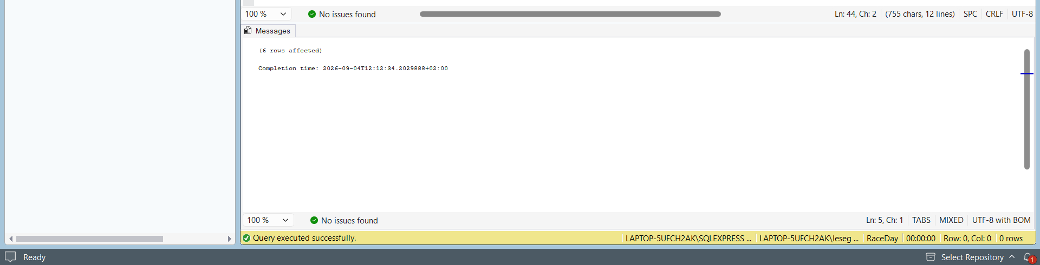
DECLARE @Cat10K UNIQUEIDENTIFIER = (SELECT [CategoryId] FROM [dbo].[Category] WHERE [CategoryName] = '10K');
DECLARE @CatHM UNIQUEIDENTIFIER = (SELECT [CategoryId] FROM [dbo].[Category] WHERE [CategoryName] = 'Half Marathon');
DECLARE @Cat1835 UNIQUEIDENTIFIER = (SELECT [CategoryId] FROM [dbo].[Category] WHERE [CategoryName] = '18-35');

INSERT INTO [dbo].[EventCategory] ([EventId], [CategoryId]) VALUES
(@Event1, @Cat10K),
(@Event2, @CatHM),
(@Event3, @Cat1835);

DECLARE @EC2 UNIQUEIDENTIFIER = (SELECT [EventCategoryId] FROM [dbo].[EventCategory] WHERE [EventId] = (SELECT [EventId] FROM [dbo].[Event] WHERE [EventName] = 'Johannesburg Half Marathon') AND [CategoryId] = (SELECT [CategoryId] FROM [dbo].[Category] WHERE [CategoryName] = 'Half Marathon'));
DECLARE @EC3 UNIQUEIDENTIFIER = (SELECT [EventCategoryId] FROM [dbo].[EventCategory] WHERE [EventId] = (SELECT [EventId] FROM [dbo].[Event] WHERE [EventName] = 'Cape Town Cycle Challenge') AND [CategoryId] = (SELECT [CategoryId] FROM [dbo].[Category] WHERE [CategoryName] = '18-35'));
DECLARE @Part1 UNIQUEIDENTIFIER = (SELECT [UserId] FROM [dbo].[User] WHERE [Email] = 'participant1@raceday.co.za');
DECLARE @Part2 UNIQUEIDENTIFIER = (SELECT [UserId] FROM [dbo].[User] WHERE [Email] = 'participant2@raceday.co.za');
DECLARE @Part3 UNIQUEIDENTIFIER = (SELECT [UserId] FROM [dbo].[User] WHERE [Email] = 'participant3@raceday.co.za');
INSERT INTO [dbo].[Enrolment] ([ParticipantId], [EventCategoryId], [EmergencyContact], [EnrolmentStatus]) VALUES
(@Part1, @EC1, N'555-0001', N'Active'),
(@Part2, @EC1, N'555-0002', N'Active'),
(@Part3, @EC2, N'555-0003', N'Active'),
(@Part1, @EC2, N'555-0001', N'Active');

DECLARE @Enrol1 UNIQUEIDENTIFIER = (SELECT TOP 1 [EnrolmentId] FROM [dbo].[Enrolment] WHERE [ParticipantId] = (SELECT [UserId] FROM [dbo].[User] WHERE [Email] = 'participant1@raceday.co.za') AND [EventCategoryId] = (SELECT [EventCategoryId] FROM [dbo].[EventCategory] WHERE [EventId] = (SELECT [EventId] FROM [dbo].[Event] WHERE [EventName] = 'Pretoria 10K Run')));
DECLARE @Enrol2 UNIQUEIDENTIFIER = (SELECT TOP 1 [EnrolmentId] FROM [dbo].[Enrolment] WHERE [ParticipantId] = (SELECT [UserId] FROM [dbo].[User] WHERE [Email] = 'participant2@raceday.co.za') AND [EventCategoryId] = (SELECT [EventCategoryId] FROM [dbo].[EventCategory] WHERE [EventId] = (SELECT [EventId] FROM [dbo].[Event] WHERE [EventName] = 'Pretoria 10K Run')));
DECLARE @Enrol3 UNIQUEIDENTIFIER = (SELECT TOP 1 [EnrolmentId] FROM [dbo].[Enrolment] WHERE [ParticipantId] = (SELECT [UserId] FROM [dbo].[User] WHERE [Email] = 'participant3@raceday.co.za') AND [EventCategoryId] = (SELECT [EventCategoryId] FROM [dbo].[EventCategory] WHERE [EventId] = (SELECT [EventId] FROM [dbo].[Event] WHERE [EventName] = 'Johannesburg Half Marathon')));
INSERT INTO [dbo].[Result] ([EnrolmentId], [FinishTime], [Position], [ChipNumber], [Status]) VALUES
(@Enrol1, CAST('00:45:32' AS TIME), 1, N'CHIP001', N'Finished'),
(@Enrol2, CAST('00:48:15' AS TIME), 2, N'CHIP002', N'Finished'),
(@Enrol3, CAST('01:52:44' AS TIME), 1, N'CHIP003', N'Finished');
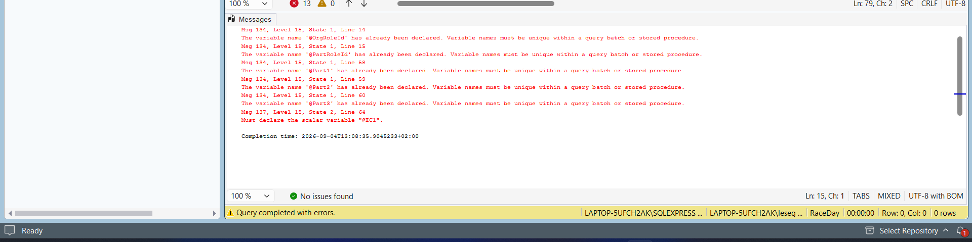
SELECT 'UserRole' AS TableName, COUNT(*) AS RecordCount FROM [dbo].[UserRole]
UNION ALL
SELECT 'User', COUNT(*) FROM [dbo].[User]
UNION ALL
SELECT 'Event', COUNT(*) FROM [dbo].[Event]
UNION ALL
SELECT 'Category', COUNT(*) FROM [dbo].[Category]
UNION ALL
SELECT 'EventCategory', COUNT(*) FROM [dbo].[EventCategory]
UNION ALL
SELECT 'Enrolment', COUNT(*) FROM [dbo].[Enrolment]
UNION ALL
SELECT 'Result', COUNT(*) FROM [dbo].[Result]
ORDER BY TableName;
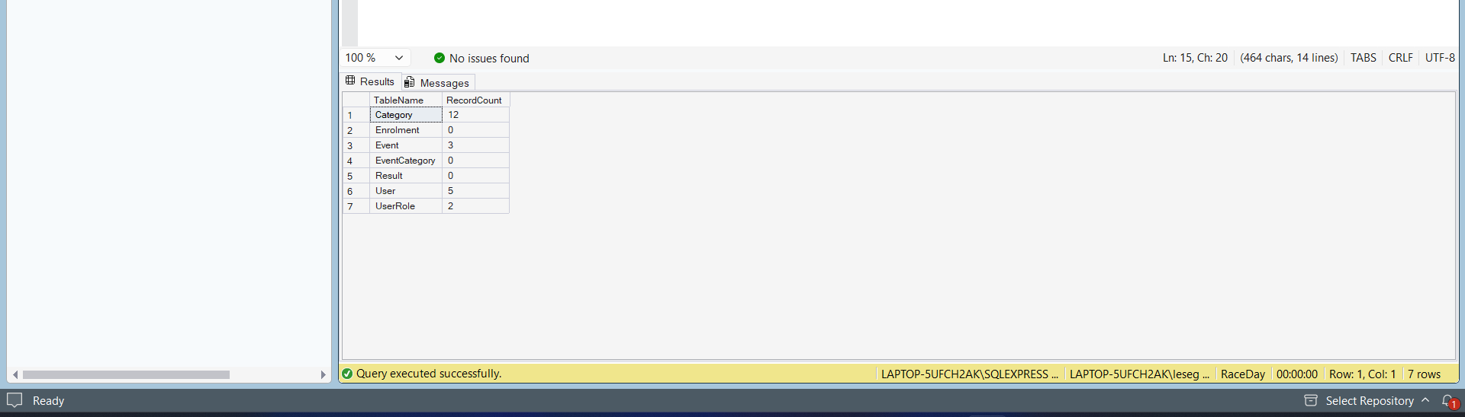
SELECT
u.[FirstName],
u.[LastName],
u.[Email],
r.[RoleName] AS Role
FROM [dbo].[User] u
JOIN [dbo].[UserRole] r ON u.[UserRoleId] = r.[UserRoleId]
ORDER BY u.[FirstName];

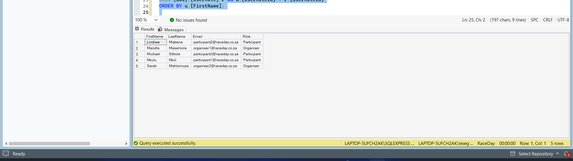
SELECT
e.[EventName],
e.[Location],
e.[Distance],
e.[EventDate]
FROM [dbo].[Event] e
ORDER BY e.[EventDate];

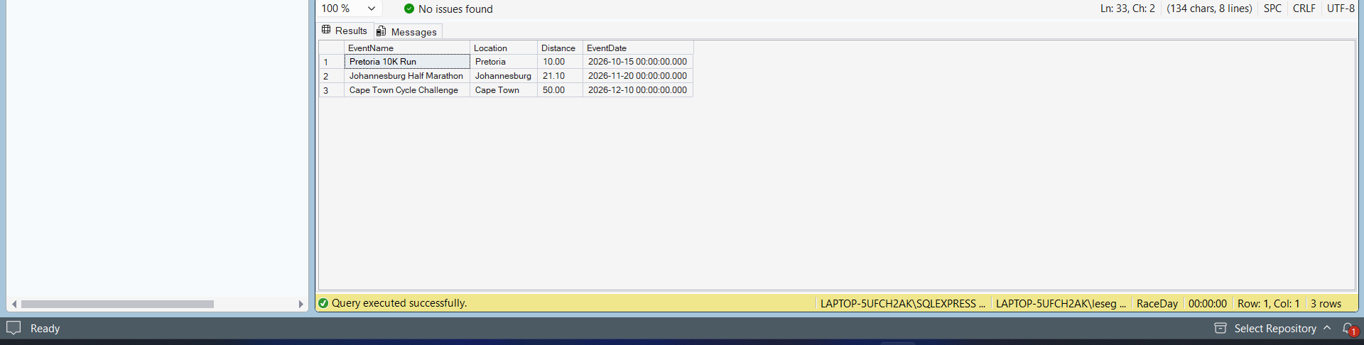
ELECT
[CategoryName],
[Description],
[MinAge],
[MaxAge]
FROM [dbo].[Category]
ORDER BY [CategoryName];

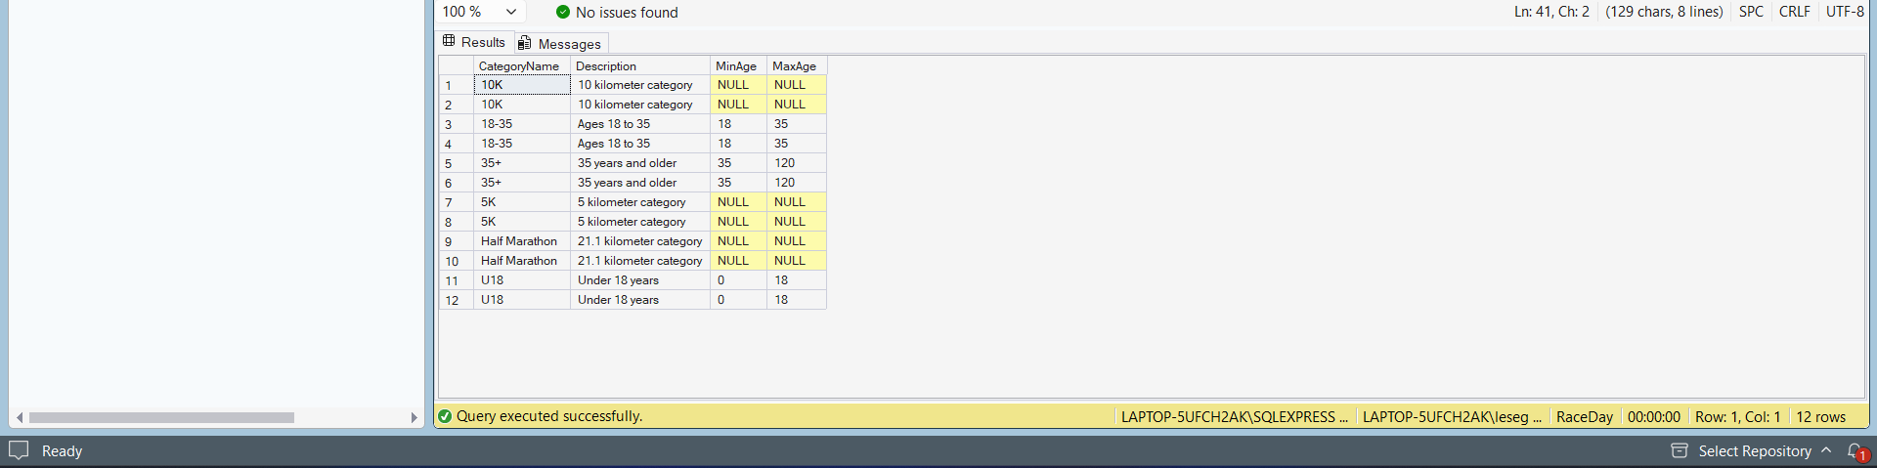
SELECT
u.[FirstName] + ' ' + u.[LastName] AS ParticipantName,
e.[EventName],
c.[CategoryName],
en.[EnrolmentStatus]
FROM [dbo].[Enrolment] en
JOIN [dbo].[User] u ON en.[ParticipantId] = u.[UserId]
JOIN [dbo].[EventCategory] ec ON en.[EventCategoryId] = ec.[EventCategoryId]
JOIN [dbo].[Event] e ON ec.[EventId] = e.[EventId]
JOIN [dbo].[Category] c ON ec.[CategoryId] = c.[CategoryId]
ORDER BY u.[FirstName];

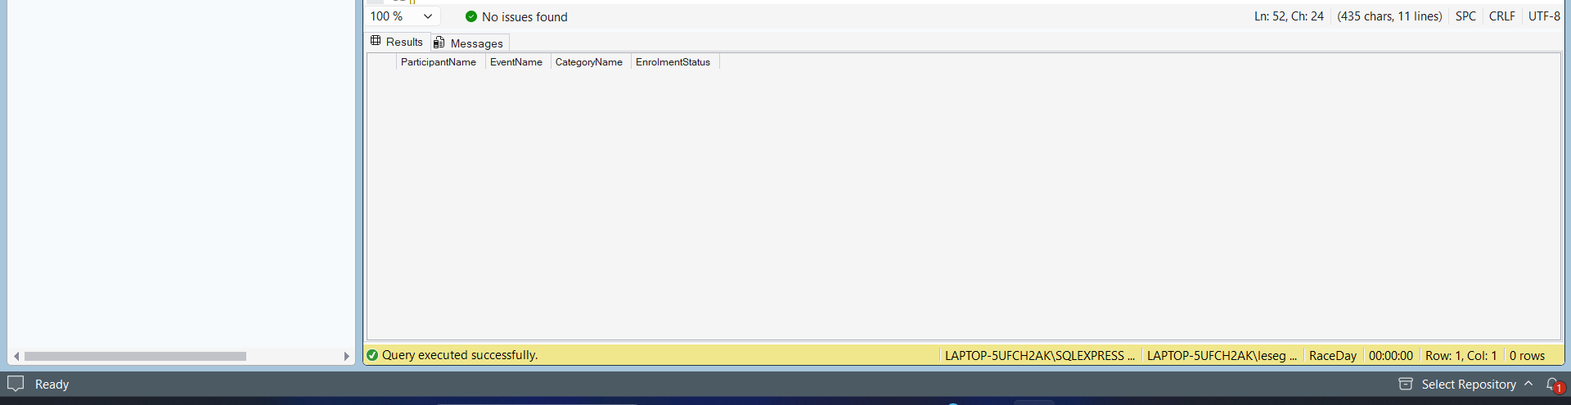
SELECT
u.[FirstName] + ' ' + u.[LastName] AS ParticipantName,
e.[EventName],
r.[Position],
r.[FinishTime],
r.[ChipNumber]
FROM [dbo].[Result] r
JOIN [dbo].[Enrolment] en ON r.[EnrolmentId] = en.[EnrolmentId]
JOIN [dbo].[User] u ON en.[ParticipantId] = u.[UserId]
JOIN [dbo].[EventCategory] ec ON en.[EventCategoryId] = ec.[EventCategoryId]
JOIN [dbo].[Event] e ON ec.[EventId] = e.[EventId]
ORDER BY e.[EventName], r.[Position];

